**Ansible installation**

* EPEL is nothing but it enables some repositories under /etc/yum/repositories/d
* We can install that with the command in website
* We can just make it fast, make it load by running the below command
* **Sudo yum install ansible**
* **Sudo yum install <url>**
* **Yum makecache**

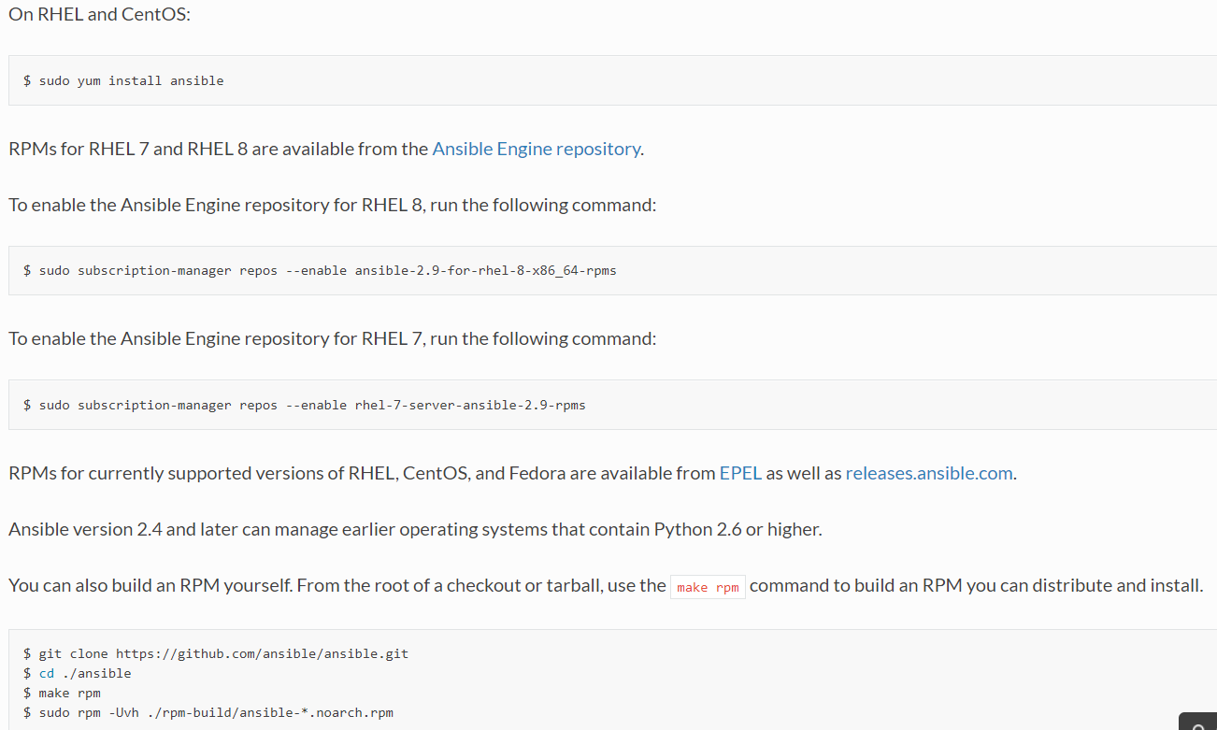

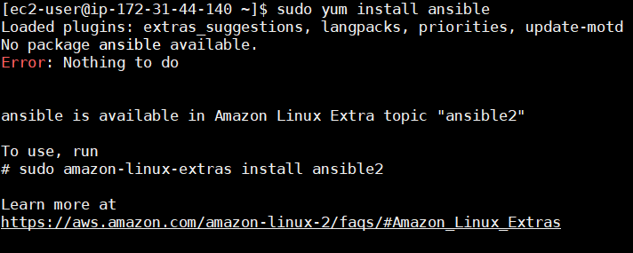

* Then we can install ansible by using yum install ansible command or we can go for the package in release folder from ansible repository and copy the link to install with yum
* We can use below command to check the version
* **Ansible - -version**
* We can also download using python installer pip

**Creating dedicated user for ansible:**

* Create an ansible user who can access ansible
* From root user, open **visudo**
* In that, enter user name to allow root user execution permissions with sudo as below



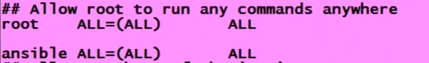

* After this, we can use sudo

**Password authentication:**

* By default, in aws we don’t need password authentication. We need username and key for authentication
* To change that, edit **/etc/ssh/sshd_config** file and set password authentication as yes. By default, it is set as no



* After this, we need to restart ssh service by using the below command
* **Service ssh restart (in ubuntu)**
* **Service sshd restart (in redhat)**
* To check that, use below command. As we are checking from same server. So, we can mention localhost
* **Ssh ansible@localhost**
* We need to do all the things like creating user and giving permissions on other servers also
* On node machines, python and user has to be present. That is enough
* Just type **python** to check if its installed or not. To exit from that use exit()
* **Python -version (to check the version)**
* Now, create a user and give the permissions as just like above
* Do the same for another node also
* Now check whether both machines can access each other by using below command
* **Ssh ansible@IP (private/public)**
* **Ssh IP**
* Both are running on same AWS network, so we can use either public or private IP

**Password less authentication between servers:**

* But every time we no need to use password while connecting the server. We can generate the key for that as below
* **Ssh-keygen**
* After the key generated, we will be having public and private key. We need to copy one to another machine as below
* Whenever we generate key. It creates public and private. We copy public to the other machine
* **Ssh-copy-id ansible@privateDNS**



* we can copy the same key to another node also
* We can use the machine hostname also instead of private DNS
* Now, we can just connect the machine with its machine name or DNS name. no need of giving username and password
* For ec2-user, it is there by default. We no need to generate and copy a key
* **Ssh privateDNS or hostname**
* Now, most of the cases linux is coming with python installed in it

**Another way:**

Run the below command in master server

* **ssh-keygen -t rsa**

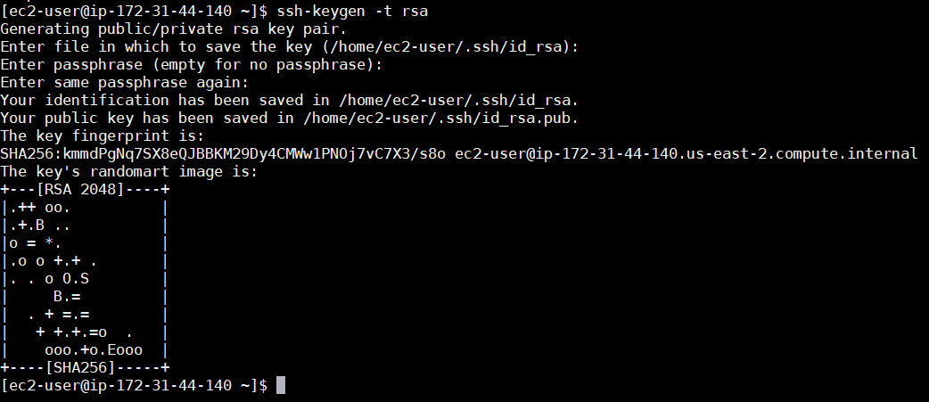

* Now, we need create ~/.ssh folder in node server if it is not existing or we can do ssh from master server with password by creating ssh folder as below.

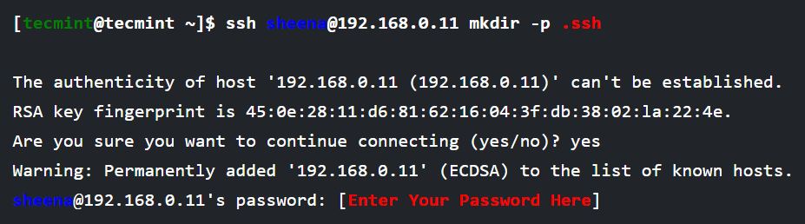

* We need to copy the public key generated in master server from **“~/.ssh/id_rsa.pub”** to **“~/.ssh/authorized_keys”** in node servers or we can do as below also.

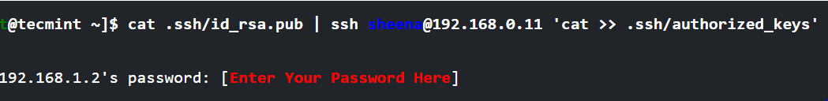

Due to different SSH versions on servers, we need to set permissions on .ssh directory and authorized_keys file.

* **chmod 700 .ssh**
* **chmod 640 .ssh/authorized_keys**

now, we can simply ssh into the node server as below without password.

* **ssh user@IP**

**For the new users:**

You have to create the .ssh directory and the authorized_keys file the first time.

Create the .ssh directory:

* **mkdir ~/.ssh**

Set the right permissions:

* **chmod 700 ~/.ssh**

Create the authorized_keys file:

* **touch ~/.ssh/authorized_keys**

Set the right permissions:

* **chmod 600 ~/.ssh/authorized_keys**

The permissions are important! It won't work without the right permissions!

Now you can add the public key to the authorized_keys file:

* **cat ~/.ssh/id_rsa.pub >> ~/.ssh/authorized_keys**

